CSA-1702 ARTIFICIAL INTELLIGENCE

Program-1:

1. Write a python program to implement Simple Calculator program.

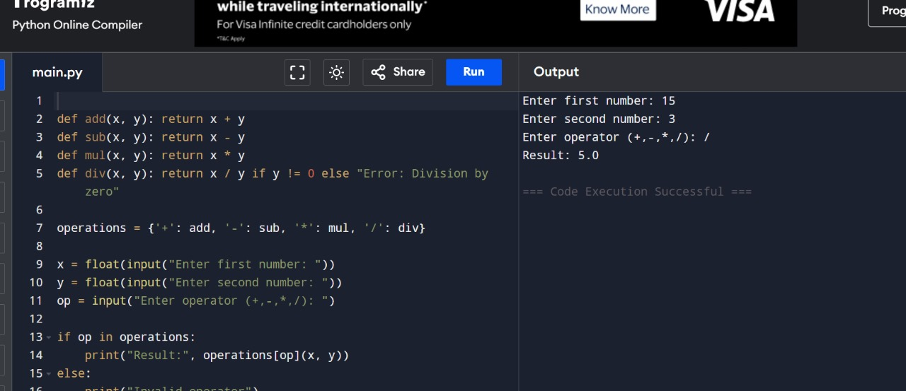

1. Write a python program to Add Two Matrices.

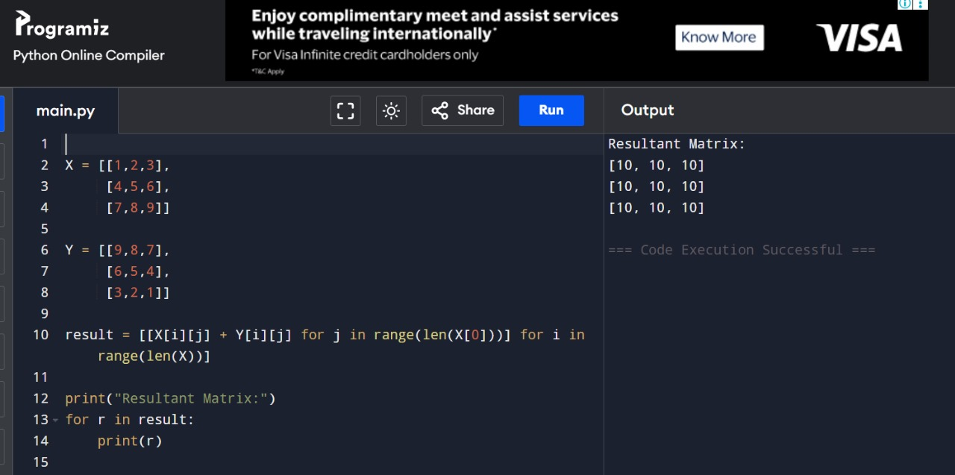

1. Write a python program to Transpose a Matrix.

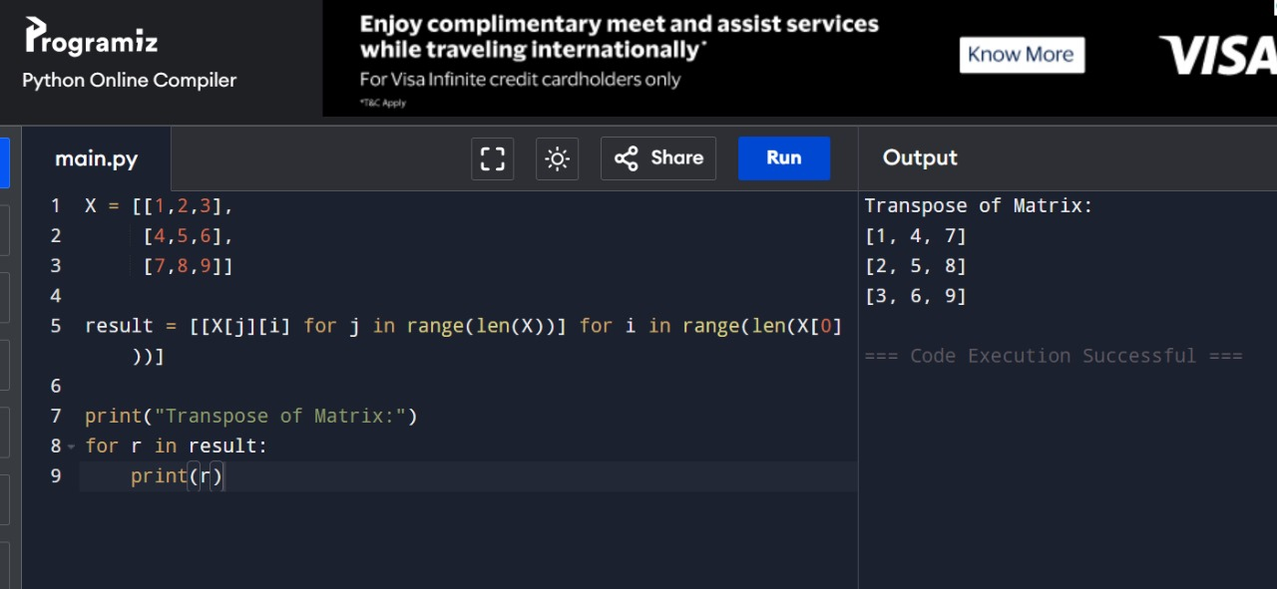

1. Write a python program to sort the sentence in alphabetical order?

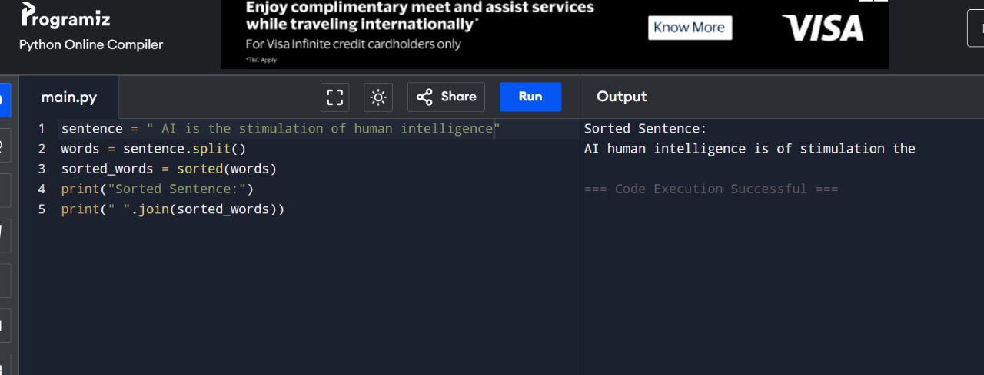

1. Write a python program to implement List operations (Nested List, Length, Concatenation, Membership, Iteration, Indexing and Slicing)?

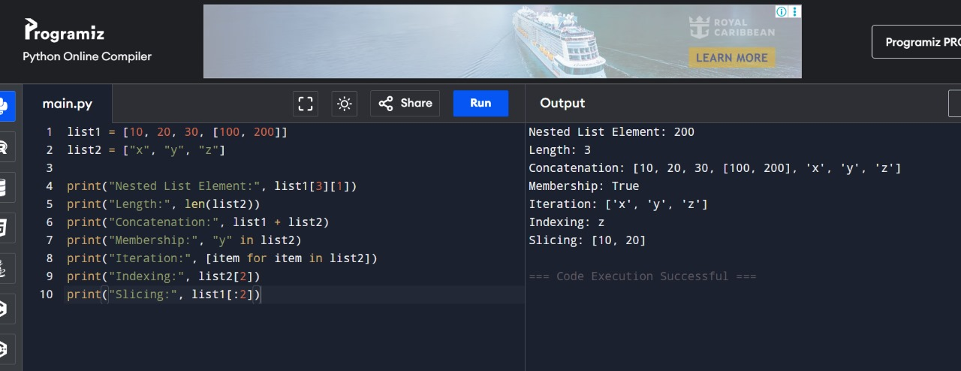

1. Write a python program to implement List methods (Add, Append, Extend & Delete).

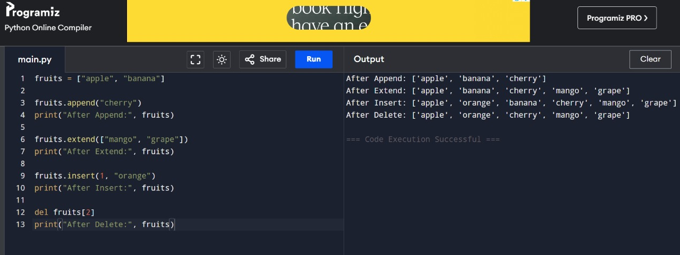

1. Write a python program to Illustrate Different Set Operations?

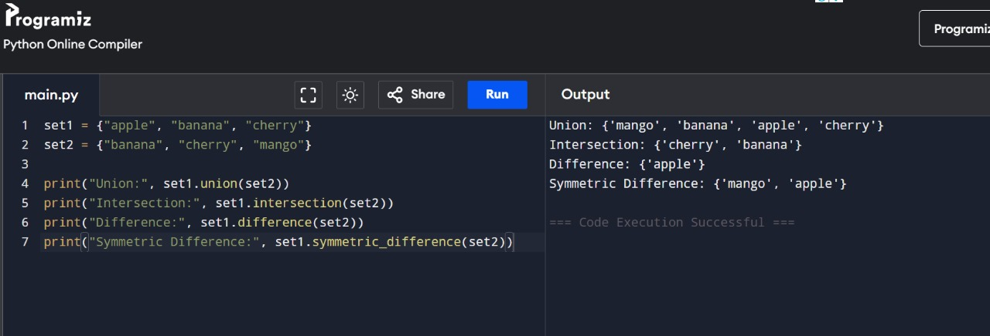

1. Write a python program to generate Calendar fthe given month and year?

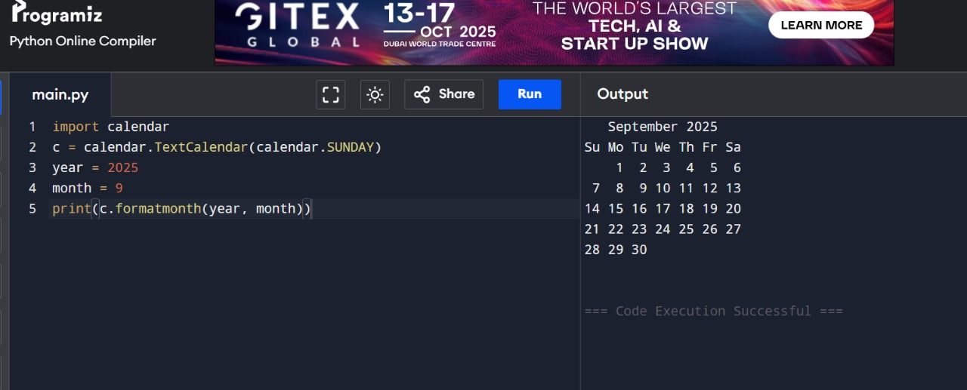

9 .Write a python program to remove punctuations from the given string?

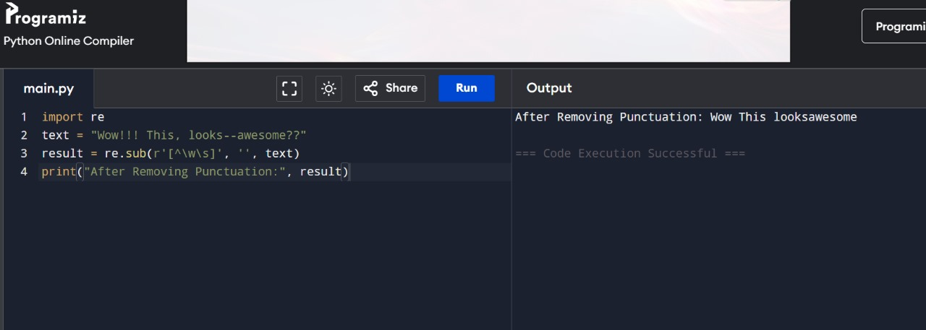

10 .Write the python program to solve 8-Puzzle problem.

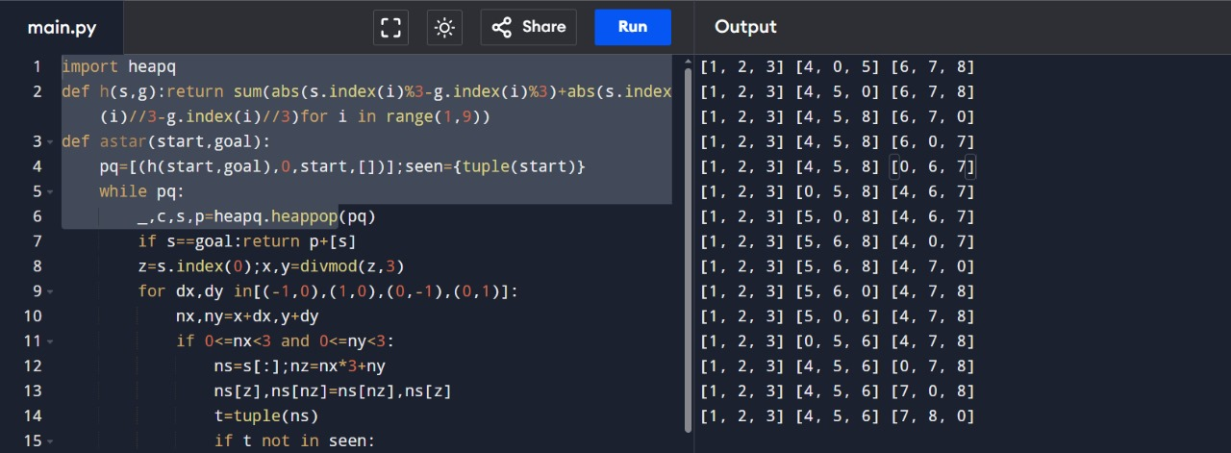

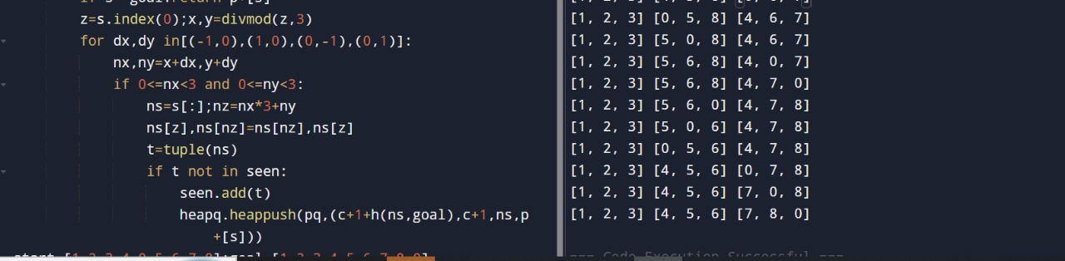

11 .Write the python program to solve 8-Queen problem.

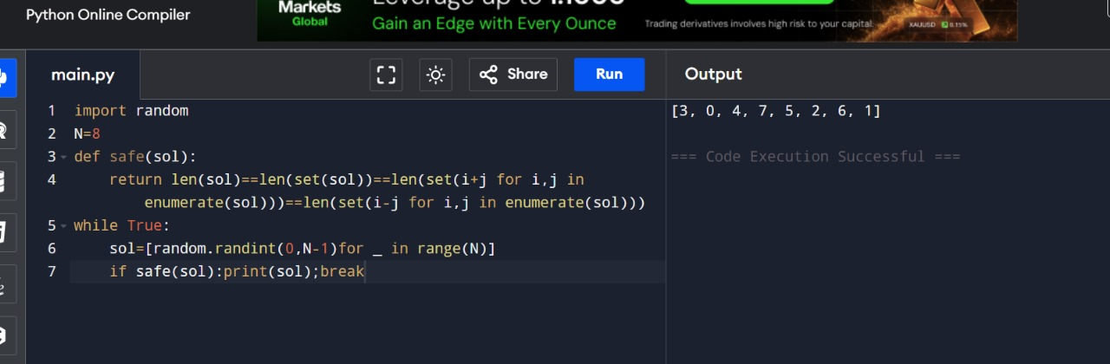

1. Write the python program for Water Jug Problem.

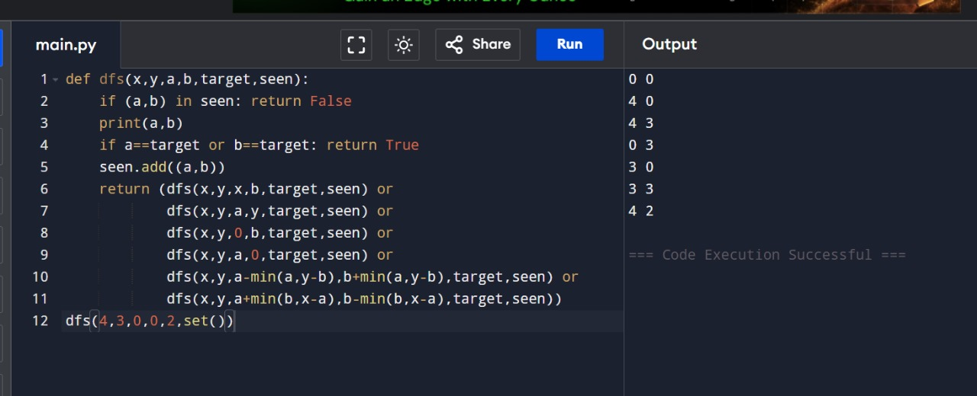

13 .Write the python program for Cript-Arithmetic problem.

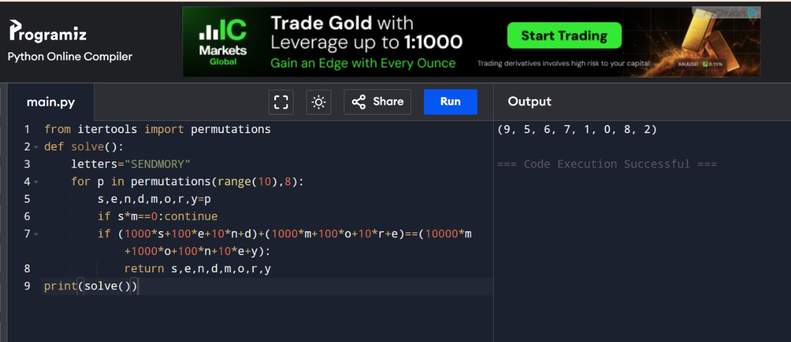

14 .Write the python program for Missionaries Cannibal problem

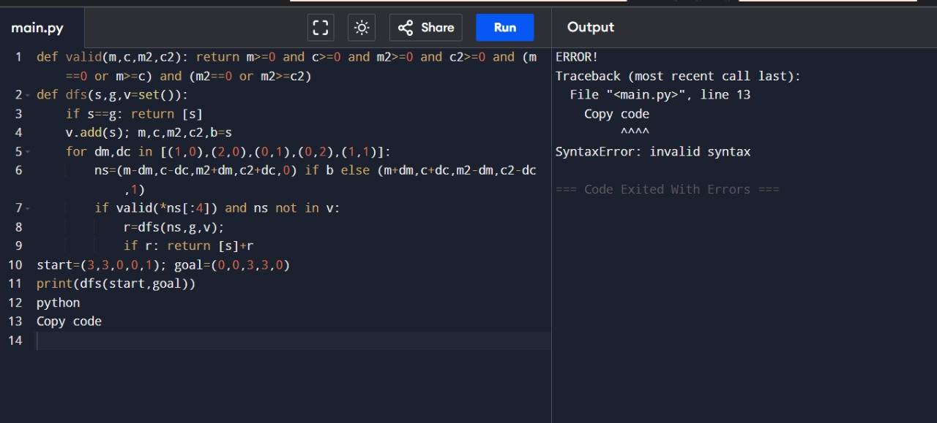

1. Write the python program for Vacuum Cleaner problem

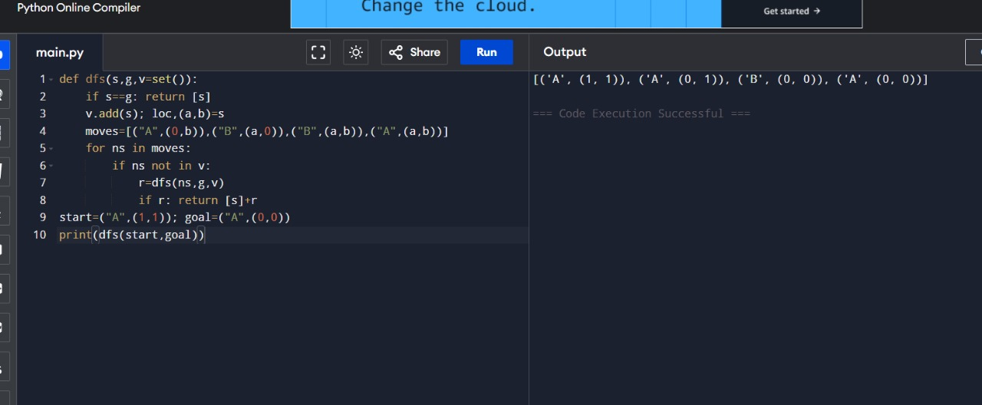

16 .Write the python program to implement BFS.

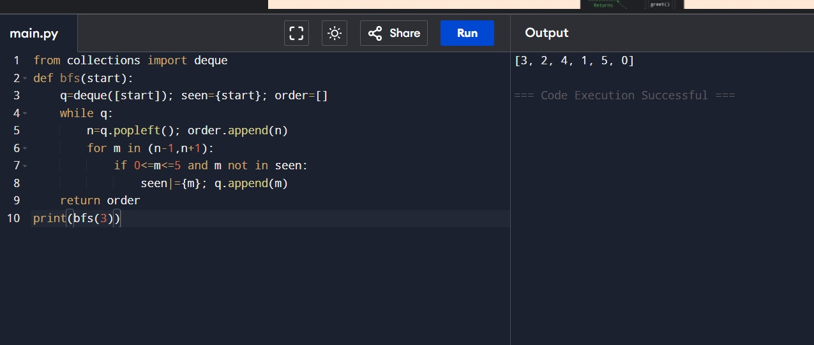

17Write the python program to implement DFS.

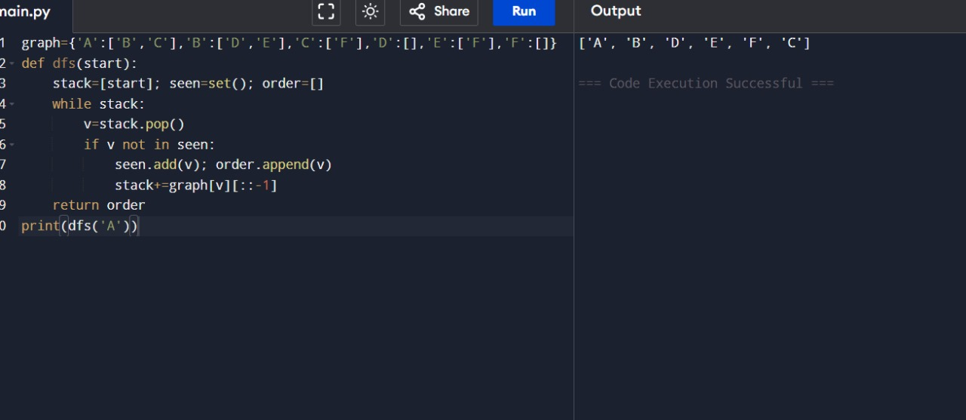

18 .Write the python to implement Travelling Salesman Problem.

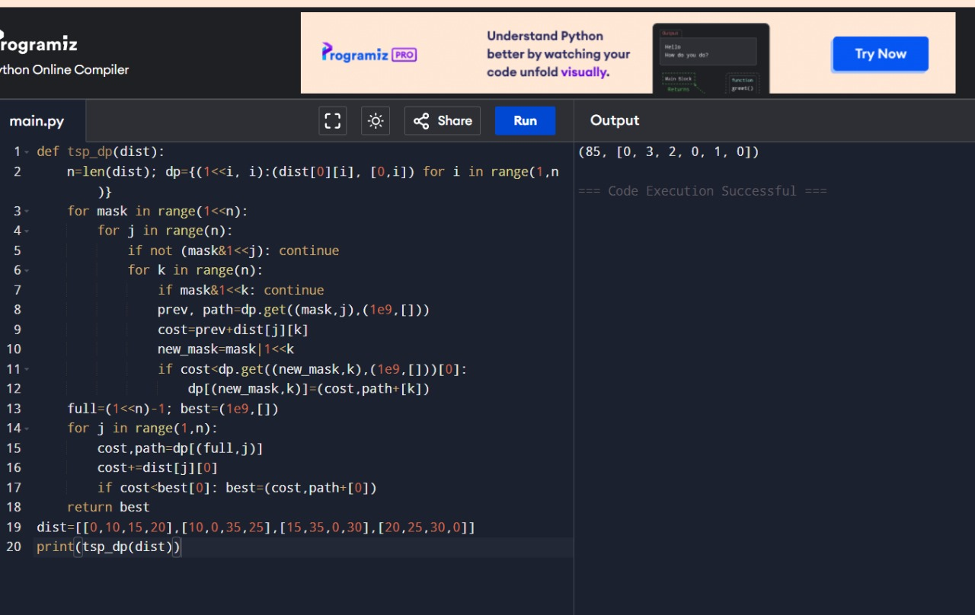

19 .Write the python program to implement A\* algorithm

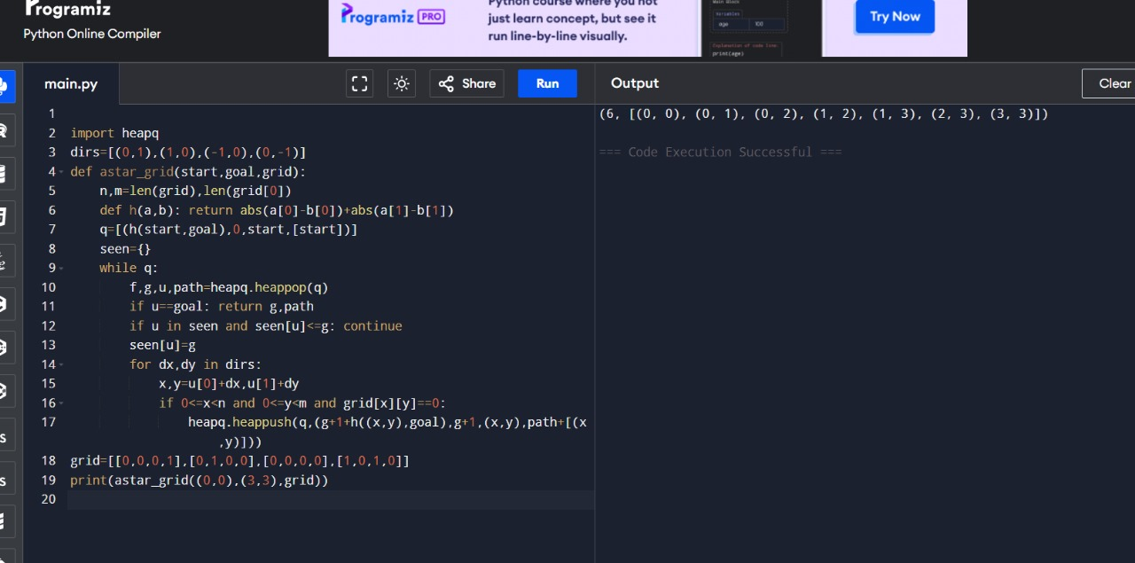

20 .Write the python program for Map Coloring to implement CSP.

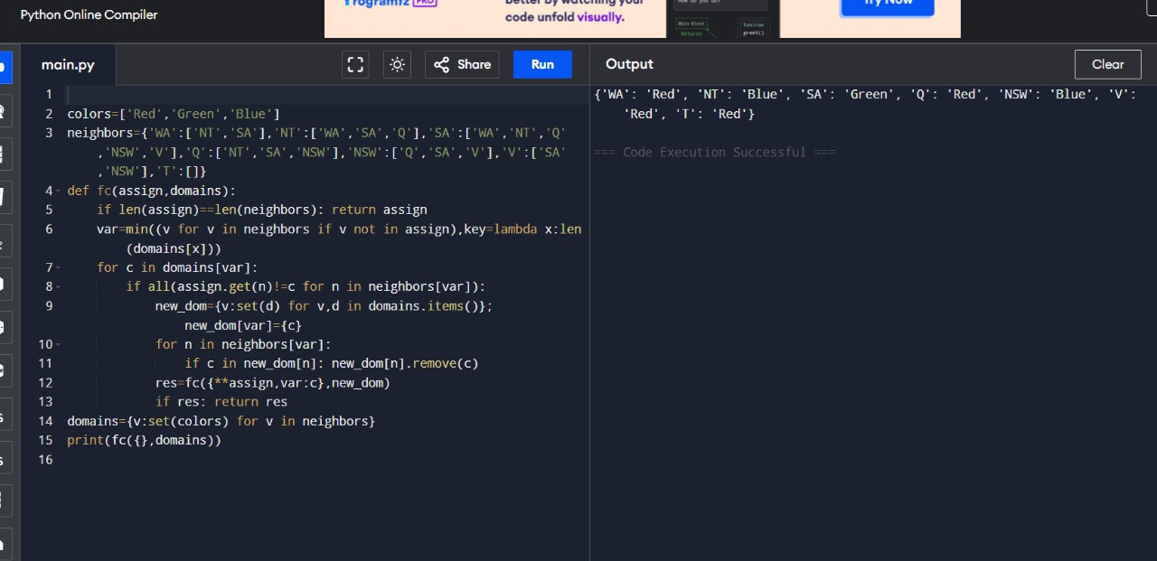

21 .Write the python program for Tic Tac Toe game .

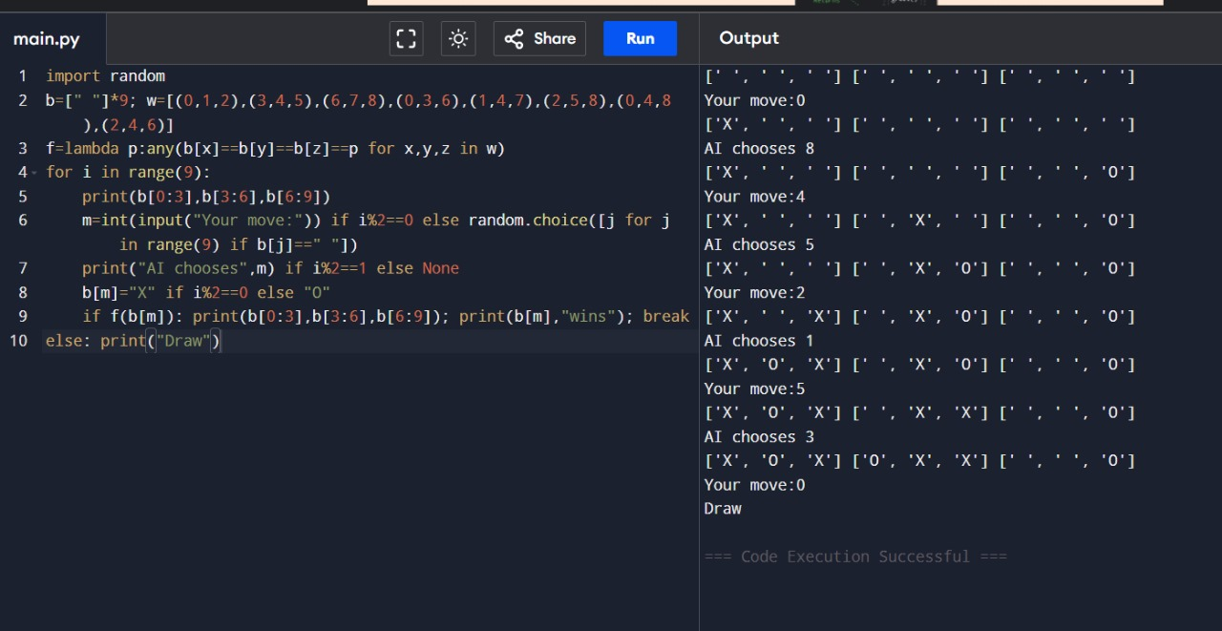

22 .Write the python program to implement Minimax algorithm for gaming

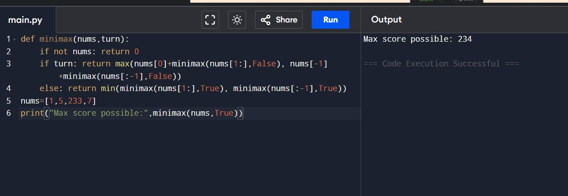

23 .Write the python program to implement Apha & Beta pruning algorithm for gaming

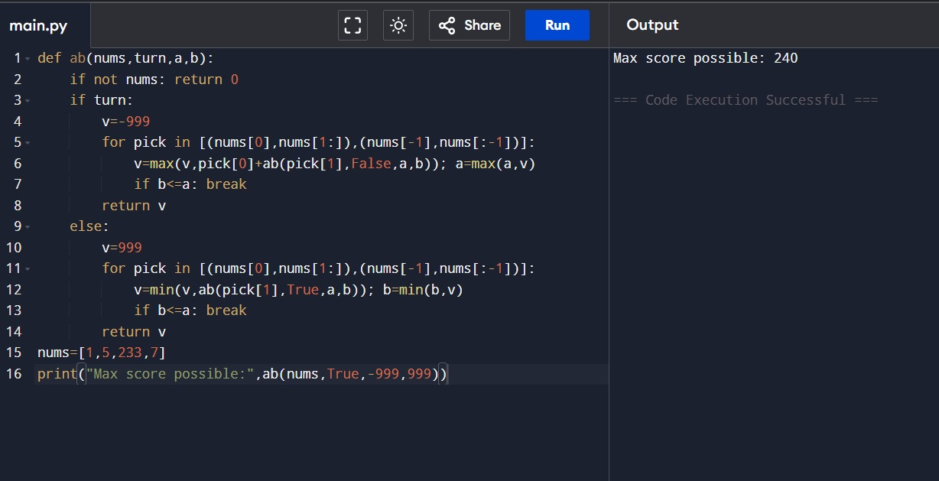

24 .Write the python program to implement Decision Tree.

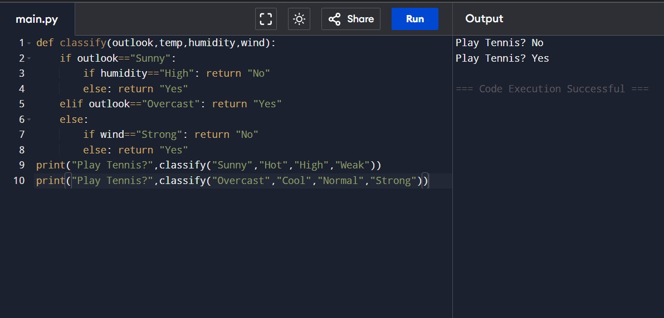

25 .Write the python program to implement Feed forward neural Network .

